1.Design a login page?

Code:

<LinearLayout android:layout_height="match_parent"
android:layout_width="match_parent"
android:orientation="vertical"
android:background="#8b8989"
xmlns:android="http://schemas.android.com/apk/res/android">
<TextView
android:layout_width="match_parent"
android:layout_height="wrap_content"
android:text="USERNAME"
android:textColor="#ff000000"
android:layout_marginTop="22dp"
android:textSize="20dp"
android:textStyle="bold"/>
<EditText
android:layout_width="match_parent"
android:layout_height="wrap_content"
android:hint="ENTER YOUR USERNAME"
android:layout_marginTop="22dp"/>
<TextView
android:layout_width="match_parent"
android:layout_height="wrap_content"
android:text="PASSWORD"
android:textColor="#ff000000"
android:textSize="20dp"
android:layout_marginTop="22dp"
android:textStyle="bold"/>
<EditText
android:layout_width="match_parent"
android:layout_height="wrap_content"
android:hint="ENTER YOUR PASSWORD"
android:inputType="textPassword"
android:layout_marginTop="22dp"/>
<Button
android:layout_width="wrap_content"
android:layout_height="wrap_content"
android:layout_gravity="center"
android:layout_marginTop="22dp"
android:text="LOG IN"
android:textSize="23dp"
android:textColor="#000000 "
android:background="#1e90ff "
android:textStyle="bold"/>
</LinearLayout>

output:
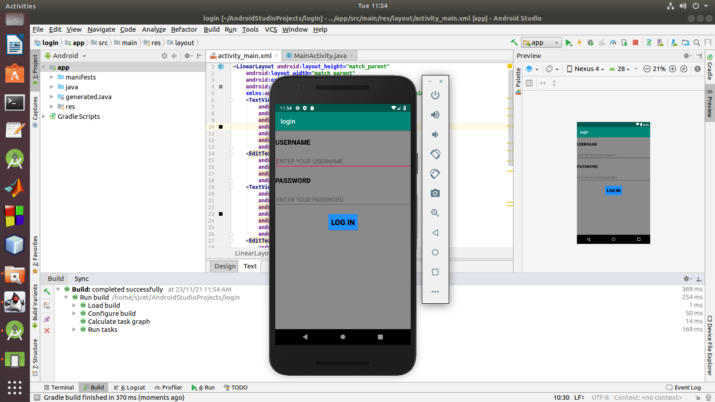

2.change the content in the textview on a button click

code:

<LinearLayout android:layout_width="match_parent"
android:layout_height="match_parent"
android:orientation="vertical"
xmlns:android="http://schemas.android.com/apk/res/android">
<TextView
android:id="@+id/t1"
android:layout_width="match_parent"
android:layout_height="wrap_content"
android:text="hello"
android:textSize="30dp"/>
<Button
android:id="@+id/b1"
android:layout_width="match_parent"
android:layout_height="wrap_content"
android:text="SUBMIT"
android:textSize="25dp"
android:onClick="set"/>
</LinearLayout>
java code:

package com.example.sjcet.changetextview;
import android.support.v7.app.AppCompatActivity;
import android.os.Bundle;
import android.view.View;
import android.widget.TextView;
public class MainActivity extends AppCompatActivity {
@Override
protected void onCreate(Bundle savedInstanceState) {
super.onCreate(savedInstanceState);
setContentView(R.layout.activity_main);
}
public void set(View view) {
TextView TV=(TextView)findViewById(R.id.t1);
TV.setText("Hai");
}
}
output:

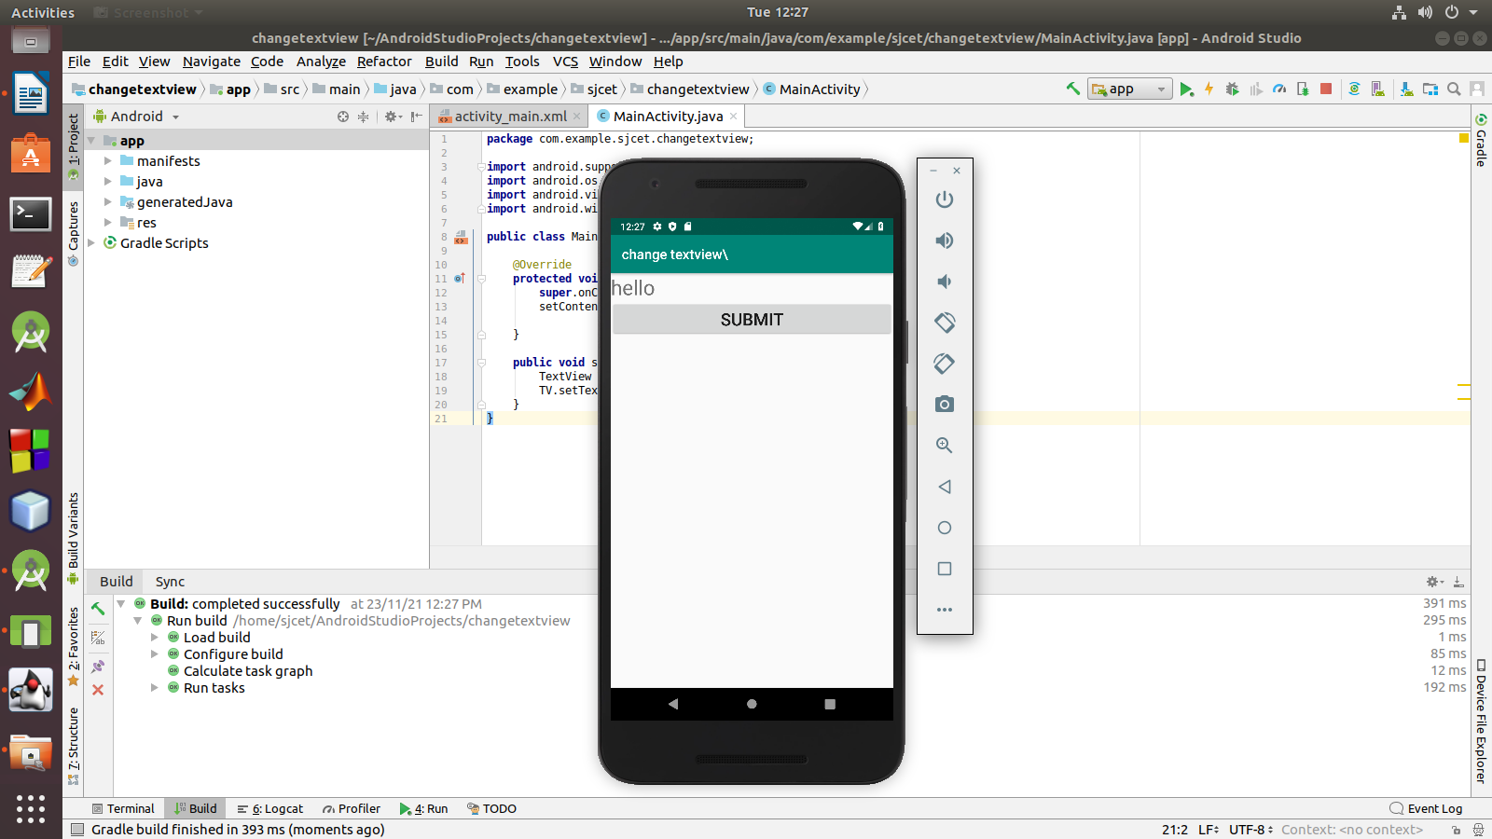
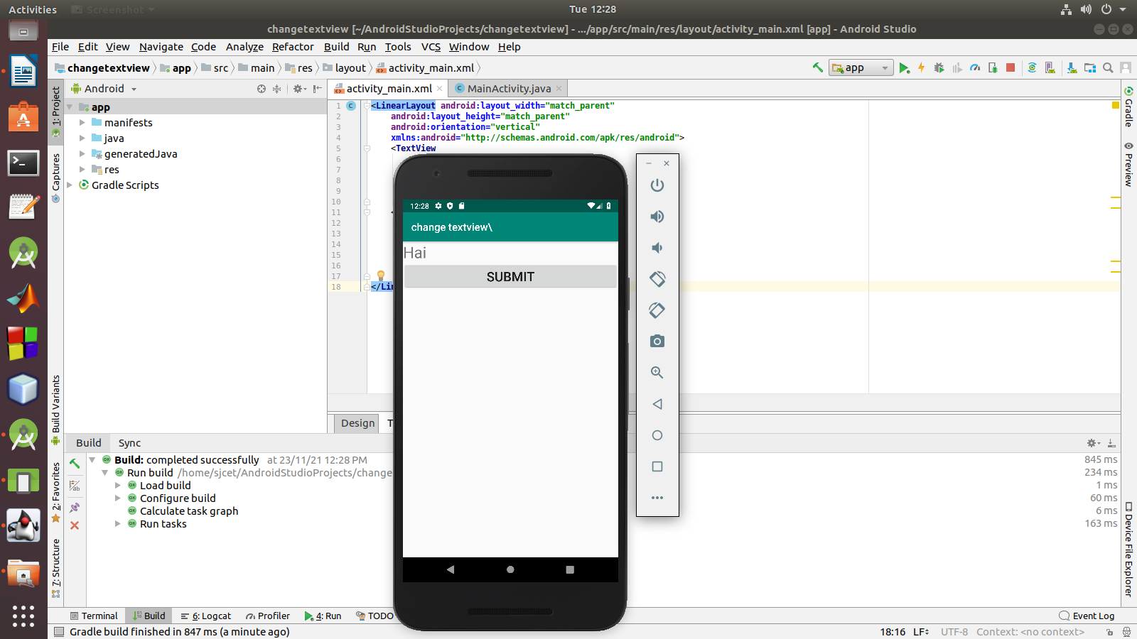
3.Read a content from edit text and print it in a textview

code:

<LinearLayout xmlns:android="http://schemas.android.com/apk/res/android"
android:layout_width="match_parent"
android:layout_height="match_parent"
android:orientation="vertical">
<EditText
android:layout_width="match_parent"
android:layout_height="wrap_content"
android:hint="Enter your Name"
android:id="@+id/et1"/>
<TextView
android:layout_width="match_parent"
android:layout_height="wrap_content"
android:text=""
android:textColor="#000000"
android:layout_marginLeft="175dp"
android:id="@+id/tv1"/>
<Button
android:layout_width="match_parent"
android:layout_height="wrap_content"
android:text="Click Here"
android:background="#32cd32"
android:textColor="#3f76ff"
android:id="@+id/btn1"
android:onClick="click"/>
</LinearLayout>
java code:

package com.example.sjcet.a3;
import android.support.v7.app.AppCompatActivity;
import android.os.Bundle;
import android.view.View;
import android.widget.EditText;
import android.widget.TextView;
public class MainActivity extends AppCompatActivity {
@Override
protected void onCreate(Bundle savedInstanceState) {
super.onCreate(savedInstanceState);
setContentView(R.layout.activity_main);
}
public void click(View view) {
EditText edit = (EditText)findViewById(R.id.et1);
TextView tview = (TextView)findViewById(R.id.tv1);
String result = edit.getText().toString();
tview.setText(result);
}
}
output:

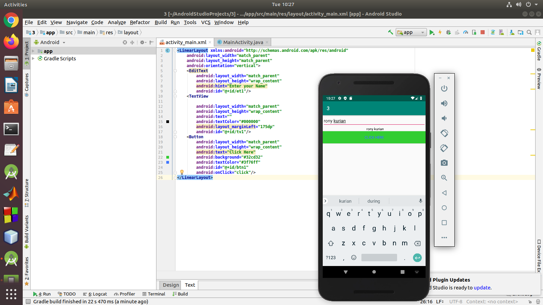
4.create the background color on a button click

code:

<LinearLayout xmlns:android="http://schemas.android.com/apk/res/android"
android:layout_width="match_parent"
android:layout_height="match_parent"
android:orientation="vertical"
android:background="#191970"
android:id="@+id/ll1">
<Button
android:layout_width="match_parent"
android:layout_height="wrap_content"
android:text="Click Here"
android:background="#32cd32"
android:textColor="#3f76ff"
android:id="@+id/btn1"
android:onClick="Click"/>
</LinearLayout>
java code:

package com.example.sjcet.a44;
import android.graphics.Color;
import android.support.v7.app.AppCompatActivity;
import android.os.Bundle;
import android.view.View;
import android.widget.LinearLayout;
public class MainActivity extends AppCompatActivity {
@Override
protected void onCreate(Bundle savedInstanceState) {
super.onCreate(savedInstanceState);
setContentView(R.layout.activity_main);
}
public void Click(View view) {
LinearLayout layout1;
layout1 = findViewById(R.id.ll1);
layout1.setBackgroundColor(Color.RED);
}
}
output:

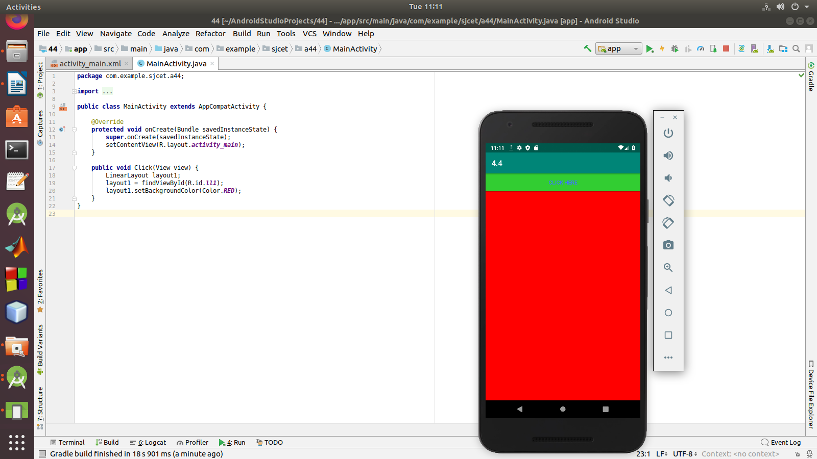

5.create a sample calculator.

Xml Code:

<LinearLayout android:layout_width="match_parent"
android:layout_height="match_parent"
android:orientation="vertical"
xmlns:android="http://schemas.android.com/apk/res/android">
<TextView
android:layout_width="match_parent"
android:layout_height="wrap_content"
android:text="CALCULATOR"
android:textSize="36dp"
android:textStyle="bold"
android:layout_marginTop="10dp"
android:layout_marginLeft="70dp"/>
<EditText
android:layout_width="match_parent"
android:layout_height="wrap_content"
android:text="Enter The first Number:"
android:id="@+id/E1"/>
<EditText
android:layout_width="match_parent"
android:layout_height="wrap_content"
android:text="Enter The Second Number:"
android:id="@+id/E2"/>
<EditText
android:layout_width="match_parent"
android:layout_height="wrap_content"
android:text=""
android:id="@+id/E3"/>
<Button
android:id="@+id/B1"
android:layout_width="80dp"
android:layout_height="wrap_content"
android:layout_marginTop="18dp"
android:layout_marginLeft="20dp"
android:text="+"
android:textSize="30dp"
android:textStyle="bold"/>
<Button
android:id="@+id/B2"
android:layout_width="80dp"
android:layout_height="wrap_content"
android:layout_marginTop="-60dp"
android:layout_marginLeft="140dp"
android:text="-"
android:textSize="30dp"
android:textStyle="bold"/>
<Button
android:id="@+id/B3"
android:layout_width="80dp"
android:layout_height="wrap_content"
android:layout_marginTop="-60dp"
android:layout_marginLeft="260dp"
android:text="*"
android:textSize="30dp"
android:textStyle="bold"/>
<Button
android:id="@+id/B4"
android:layout_width="80dp"
android:layout_height="wrap_content"
android:layout_marginTop="18dp"
android:layout_marginLeft="20dp"
android:text="/"
android:textSize="30dp"
android:textStyle="bold"/>
<Button
android:id="@+id/B5"
android:layout_width="80dp"
android:layout_height="wrap_content"
android:layout_marginTop="-60dp"
android:layout_marginLeft="140dp"
android:text="="
android:textSize="30dp"
android:textStyle="bold"/>
</LinearLayout>
java code:

package com.example.sjcet.ca;
import android.support.v7.app.AppCompatActivity;
import android.os.Bundle;
import android.view.View;
import android.widget.Button;
import android.widget.EditText;
public class MainActivity extends AppCompatActivity {
Button b1,b2,b3,b4,b5,b6;
EditText e1,e2,e3;
double ans;
@Override
protected void onCreate(Bundle savedInstanceState) {
super.onCreate(savedInstanceState);
setContentView(R.layout.activity_main);
b1 = (Button) findViewById(R.id.B1);
b2 = (Button) findViewById(R.id.B2);
b3 = (Button) findViewById(R.id.B3);
b4 = (Button) findViewById(R.id.B4);
b5 = (Button) findViewById(R.id.B5);
e1 = (EditText) findViewById(R.id.E1);
e2 = (EditText) findViewById(R.id.E2);
e3 = (EditText) findViewById(R.id.E3);
b1.setOnClickListener(new View.OnClickListener() {
@Override
public void onClick(View v) {
double a=Double.parseDouble(e1.getText().toString());
double b=Double.parseDouble((e2.getText().toString()));
ans=a+b;
}
});
b2.setOnClickListener(new View.OnClickListener() {
@Override
public void onClick(View v) {
double a=Double.parseDouble((e1.getText().toString()));
double b=Double.parseDouble((e2.getText().toString()));
ans=a-b;
}
});
b3.setOnClickListener(new View.OnClickListener() {
@Override
public void onClick(View v) {
double a=Double.parseDouble(e1.getText().toString());
double b=Double.parseDouble((e2.getText().toString()));
ans=a*b;
}
});
b4.setOnClickListener(new View.OnClickListener() {
@Override
public void onClick(View v) {
double a=Double.parseDouble(e1.getText().toString());
double b=Double.parseDouble(e2.getText().toString());
if(b!=0)
ans=a/b;
}
});
b5.setOnClickListener(new View.OnClickListener() {
@Override
public void onClick(View v) {
String ans1=String.valueOf(ans);
e3.setText(ans1);
ans=0;
}
});
}
}
output:

